Componente Curricular: Inglês Data: 14/04/2025
Professor (a): Fabíola Série: 1a
Assunto (s): Pronouns, Present and Future

PRONOUNS

1. Observe a tira:
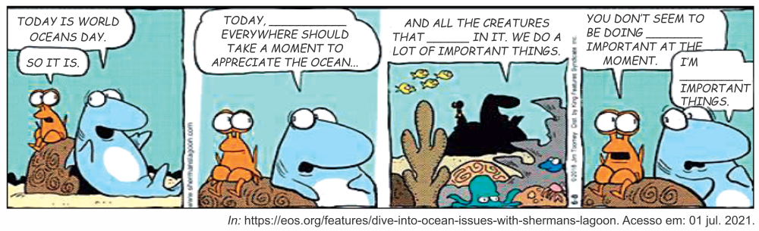
Considerando o contexto e a gramática da língua inglesa, assinale a alternativa cujas palavras completam a sequência CORRETA dos espaços nos balões da tira cômica.
A) everyone / live / anything / in between
B) anyone / lives / everything / in here
C) anyone / living / something / in between
D) no-one / lived / nothing / in front of
E) everyone / lives / anything / in there

2. Complete the sentences below with the right pronouns.
I. Mr. Michaels and ___________ will attend the presentation.
II. The exercise is very easy. ___________ can do it.
III. Give the materials to Mr. Davis and ___________ as soon as possible.
IV. ___________ students wanted their final exams immediately.
V. They have two babies and take them ___________.
VI. You and your friends should take better care of ___________.

 | I | II | III | IV | V | VI
A) | me | Anyone | her | We | anywhere | themselves
B) | I | Anyone | her | Our | everywhere | yourselves
C) | myself | No-one | she | Ours | anywhere | yourself
D) | me | Someone | she | Us | everywhere | themselves
E) | I | Someone | her | Our | anywhere | yourself

3. Read the sentences below paying special attention to the use of the pronouns.
I. The majority of us are apprehensive about new computer programs, until we’ve actually tried them out for ourselves.
II. The editor thought that the new series of articles would prove very popular, but actually hardly anyone seems to have been impressed by it.
III. They are in no way responsible; we must face the fact that we have only ourselves to blame.
IV. We always wash up the dog’s dishes separately. This cloth is for our dishes and that one is for its.
V. It’s not their deckchair. It’s ours! Don’t you recognize it?
VI. Don’t tell anyone else about the surprise party. It’s between you and me!

We can state that:
A) There are more correct than incorrect sentences.
B) There are more incorrect than correct sentences.
C) Only sentences I, II and V are correct.
D) Only sentences III, IV and VI are incorrect.
E) All the sentences are correct.

4. Complete the following article about Bhutan with the correct pronoun.

Do you know (A)____________ who’s been to Bhutan?

The Kingdom of Bhutan is a fabled tiny country tucked in the Himalayas between China and India. The mountains divide the country into a series of parallel valleys, each with distinct languages, culture, and dress. In 1907, the first King of Bhutan unified the country. The Bhutanese people love their kings, and it’s easy to see why. In 2006, King Four abdicated voluntarily from the throne to let (B)__________ son start a new political era. The monarchy relinquished their power to the people and created a democratic system, which is remarkable not only because it was symbolic of the compassion the rulers have for (C)___________ people but also because the Bhutanese people never wanted a democracy and had to be persuaded to accept their king’s abdication. The current King, Jigme Khesar Namgyel Wangchuck, is one of the world’s youngest leaders at only 34 years of age, and though his political power is limited, he has helped lead Bhutan towards (D)_______________ great and noble: the pursuit of happiness. Living in a Buddhist country, the people of Bhutan are more concerned than most with ideals of compassion, mindfulness, and awareness of the effects of your own actions.

5. Complete the following passage with the correct pronoun.
(A) ______________________ knows that advertising should be taken with a pinch of salt. If it sounds too good to be true, it probably is. Advertisers spin and shade the truth in (B) ______________________ favor. But sometimes they go a few steps too far and promote products based on outright falsehoods. From bogus cancer cures to biologically impossible weight-loss gimmicks, here are some of biggest lies ever told in advertising.

In 2009, fashion retailer Ralph Lauren put out a series of ads so heavily photoshopped that the models in (C) ______________________ appeared to have heads larger than their waists. The models weren’t able to recognize (D) ______________________. Lauren, after trying to hide the story, apologized after learning that "we are responsible for the poor imaging and retouching that resulted in a very distorted and unreal image of a woman's body."

PRESENT SIMPLE AND CONTINUOUS
1.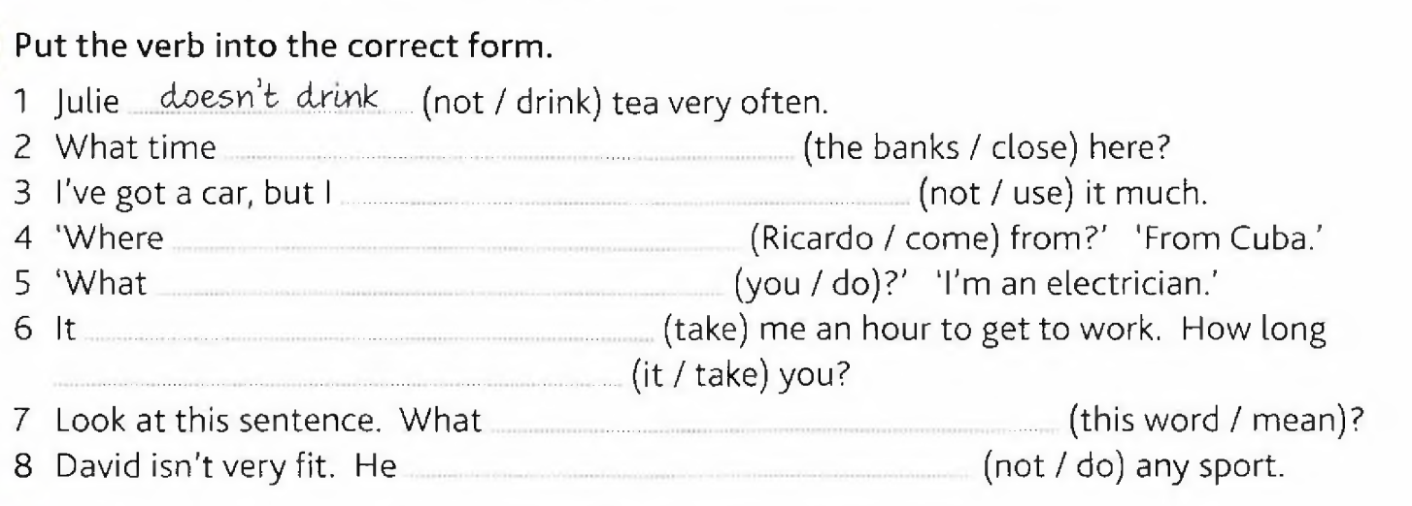
2. Read the following sentences.
- Scientists doesn’t understand everything about the universe.
- They disagree about some important facts. For example, it is getting larger or smaller?
- Although they are not agree about everything, there are some facts about the universe which they are sure about.
- Take the planet Venus, for example. Here the temperature reaches over 400ºC.
- It isn’t seem to be the kind of place where life might exist.
- The atmosphere of Venus consists mainly of Carbon dioxide.
- And it has an air pressure 90 times greater than that on Earth.

Now choose the correct alternative, regarding only the grammar aspects.
- All the sentences are grammatically correct.
- All the sentences are grammatically incorrect.
- The sentences II, III, IV and V are grammatically incorrect.
- The sentences IV and VI and VII are grammatically correct.
- The sentences I, IV, V, VI and VII are grammatically correct.

3. Read the sentences below paying special attention to the use of the verb tenses and forms.
I. What do they do now?
II. Who like chocolate?
III. Where is Tom and Pauline?
IV. Lisa are I are good friends.
V. Pauline and Tom are singing in the school choir now.
VI. Josh doesn’t likes to play soccer on the weekends.

Now answer: what sentences are correct?
A) Only sentences I and II.
B) Only sentences II and IV.
C) Only sentences III and V.
D) Only sentences IV and VI.
E) Only sentences IV and V.

4. Read the text and choose the alternative containing the correct words to respectively complete gaps.

How does Alexa (I) _______?

Unlike a normal computer program, Alexa works using voice control. That means you have to say questions or commands out loud, and she'll respond through (II) _______ Alexa speaker. Every Alexa speaker comes equipped with far-field microphones, so she should be able to hear you from (III) ______ in the room. First, you say 'Alexa' and then the speaker will light up, at which point you'll ask your question. Your question will then be beamed across to an Amazon cloud server, where powerful computers will work out what you are trying to say. Once Amazon's computers have worked out an answer, it'll be beamed back to your Alexa speaker, and she'll tell you what you need to know. It sounds like a long and complicated process, but it actually (IV) ______ over a few milliseconds – so you should get an instant response.

- work, my, somewhere, is happening.
- work, your, anywhere, is happening.
- work, your, anywhere, happens.
- works, her, everywhere, is happening.
- works, its, somewhere, happens.

5. Complete the paragraph below with the verbs in the brackets in the right tense (Present Simple or Continuous).
'My name is Peter. l live in the suburbs of Boston with my family. Most people (A) ____________________ (believe) we (B) ____________________________ (be) rich because we live in a big house. But our family (C) ___________________________ (seem) to be like any other one. Have a look: Maggy, my wife, likes cooking. She enjoys being in the kitchen with her friends. At the moment she (D) _____________________________ (make) a cake and you can't talk to her. What really worries her is our daughter who (E) _________________________ (prefer) to chat in front of her computer instead of cooking with her. It's 5 pm now. Paul, my son, (F) ________________________ (play) basketball in the garden now and I am watching TV.

6. Choose a verb from the box below to complete the e-mail. Use the verbs in the right tense (Present Simple or Continuous). There are extra verbs. Do not repeat the words.

promise – enjoy – confess – believe – apologize – know – admit – be – worry – consider

Dear Aunt Mara,

Thanks for your message. I (A)____________________ for not getting back to you sooner, but I've been incredibly busy. When I went into nursing, you warned me that it would be really hard work, but I (B) __________________ that I didn't really believe you. Don't get me wrong - I'm not suggesting that I'm not enjoying it. It's incredibly rewarding, but I now realize how hard the job is. When I get home, I just eat (not very well, I (C) ___________________) and go straight to bed. It doesn't help that the bus journey to the hospital is so slow. I (D) ____________________ buying a car, which will make things easier, I hope.

And what about you? How do you find yourself living in a village after so many years in the city? I (E)_______________ how difficult it is for you to travel such a long way, but it would be lovely if you could come and stay with me for a weekend. I've got plenty of room in my flat. I don't guarantee to cook as well as you do, but I (F)_______________ to find time to show you around this lovely old town.

Hope to see you soon. Keep in touch.

Love,

Martina.

FUTURE (WILL AND BE GOING TO)

1. Read the following sentences.
- Look, there’s a new David Nolan movie. I think you will enjoy it.
- I’m over the moon! I’ve just found out my sister is going to have a baby next year!
- My parents have already decided: they will Toronto for their next vacation.
- Carlos, are you going to help me with my Math homework? It’s very hard!
- I got a C on my last History test. I’ve decided I will study harder for the next one so I can get an A.

Now choose the correct alternative, regarding only the grammar aspects.
A) All of the sentences are correct.
B) I and II are correct.
C) I, II and III are correct.
D) I, II and IV are incorrect.
E) All of the sentences are incorrect.
2. Read the comic strip.


(Adapted from: https://t.ly/Usijr)
Considerando o contexto e a gramática da língua inglesa, assinale a alternativa cujas palavras completam a sequência CORRETA dos espaços nos balões da tira cômica.

A) are going to look / do you think / is just screaming
B) is going to look / you think / is going to scream
C) are going to look / you think / just screams
D) will look / you think / is just scream
E) will look / do you think / will just scream

3. Complete the following paragraph with the correct form of the verbs in brackets. Use the Present Simple, Present Continuous, Be Going To or Will.
AI
We frequently see news articles and blog posts which claim that AI technology (A) ______________________ (become) exponentially more powerful over time. For teenagers, AI (B) ______________________ (present) both opportunities and challenges that shape their experiences and future prospects. Futurists are fairly universal in their opinion that AI isn’t going away. Instead, this is a technology that (C) ______________________ (not just assist) us but will serve as a collaborator. Researchers (D) _______________________ (say) that’s something everyone (E) ______________________ (need) to learn to expect. “What type of human do we need to be preparing for the world they (F) ______________________ (live) in the future?” As AI continues to advance, it creates new career opportunities for teenagers interested in technology. Given all of this, why (G) ______________________ (people have) trouble understanding exponential growth? How can we develop a better intuition for it, in order to understand what (H) ______________________ (happen) with AI technology today? Understanding all this is important so that we can be a part of the future.

